## 

Home automation system

07.07.2021

**─**By

Amal Sunil Pillai: 19030121009

Kriti Thakrar : 19030121050

Sradha S kumar : 19030121089

Umang Agrawal : 19030121093

GROUP NO : 4

# Two factor authentication (QR code and face recognition) door lock system

**Components used:**

1. Arduino uno atmega328p
2. Breadboard
3. Servo motor
4. Ldr
5. Led bulb x 2
6. Resistors (1k ohms and 10k ohms)
7. Laptop: run the python script for two factor authentication and provides power supply for the arduino board.

**Circuit Diagram:**

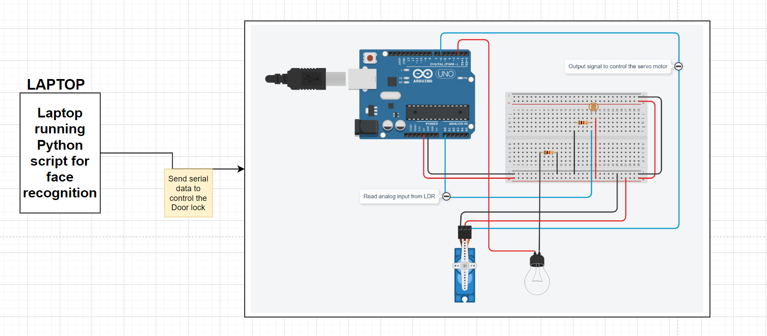

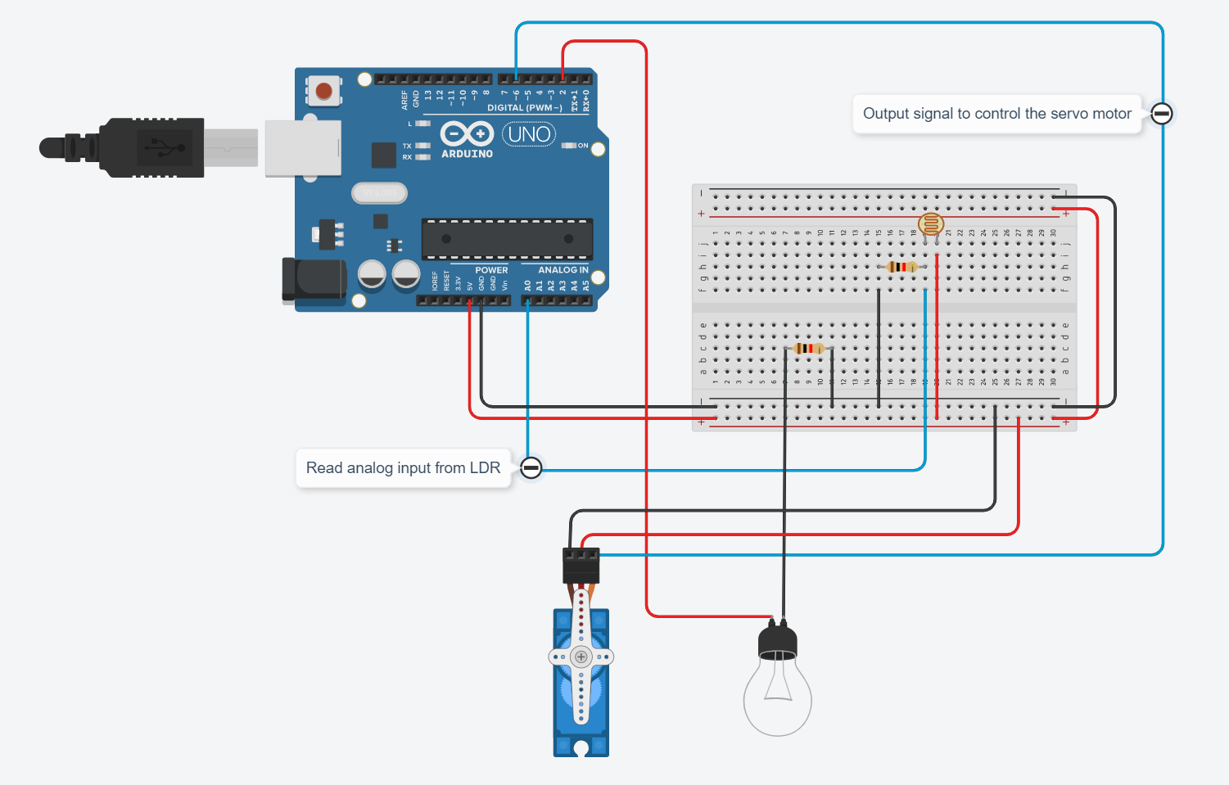

# 

# Description:

The laptop will run the python code for the two factor authentication process which consists of a QR code decoder and face recognition. Only the valid users with valid private key encoded in the QR code will be able to proceed to face recognition and once the face is recognised as a valid user, the door lock will be switched open(servo motor will turn from 0 to 90 degree).

The arduino sketch/code uploaded in the arduino board will take care about the ldr and led working, the serial signal sent from the python script will control the servo motor activation(on or off).

**Flowchart :**

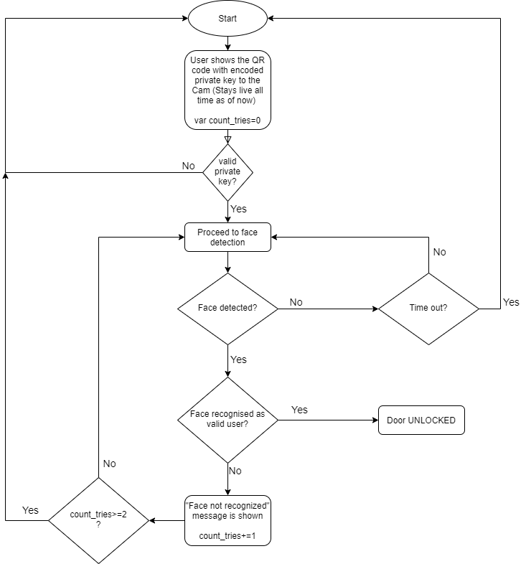

Detect human presence in the room to automatically switch off the lights and the fan

1. Components used-:
   * PIR motion sensor(Passive infrared motion sensor)
   * 1 led
   * 1 Resistor
   * Arduino uno
   * Breadboard

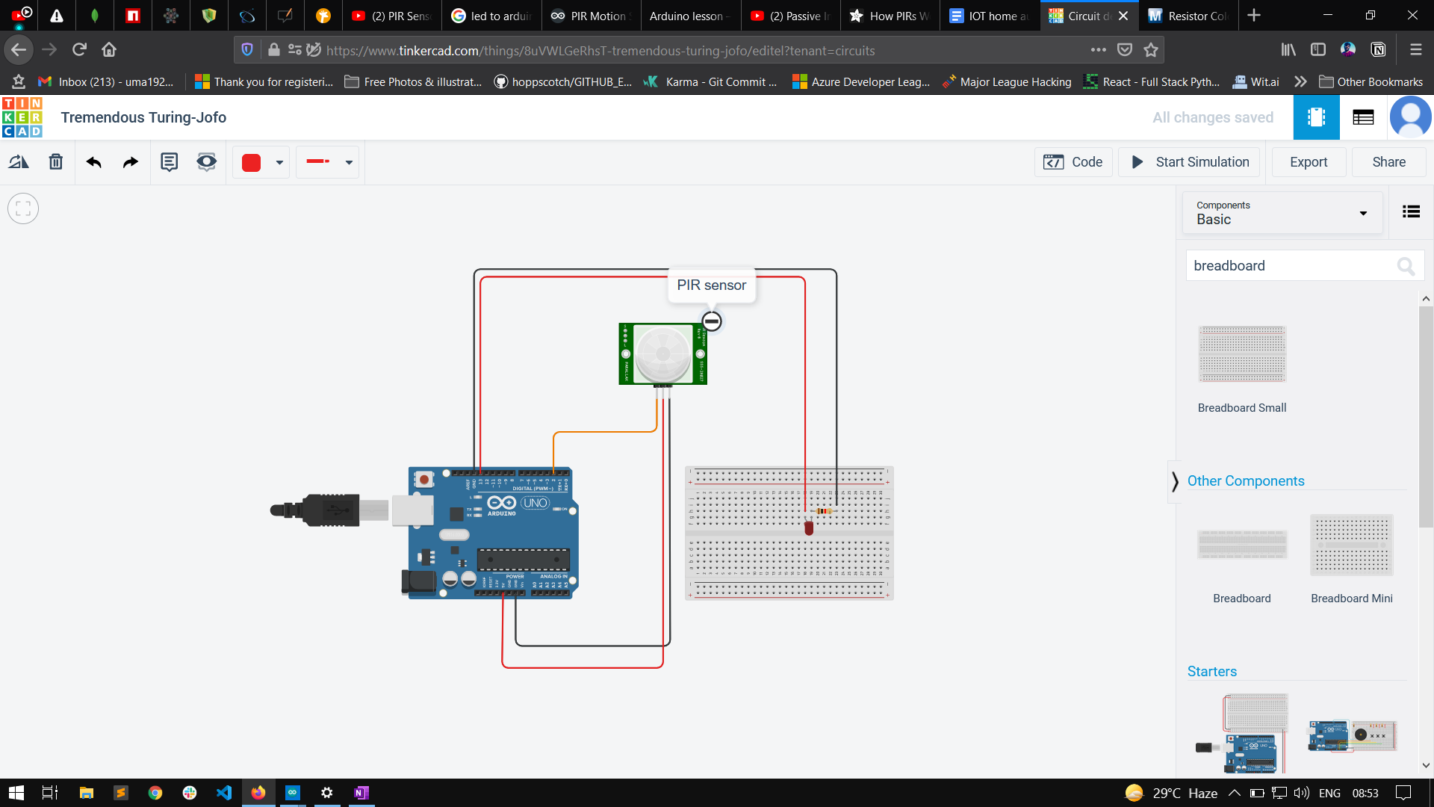

**Working-:**

PIR sensor is used to which is Passive infrared sensor, when nothing is detected in the range of the sensor , led will be turned off and when human interference is detected by the sensor in the form of infrared radiation as it detects IR, led will turn on.

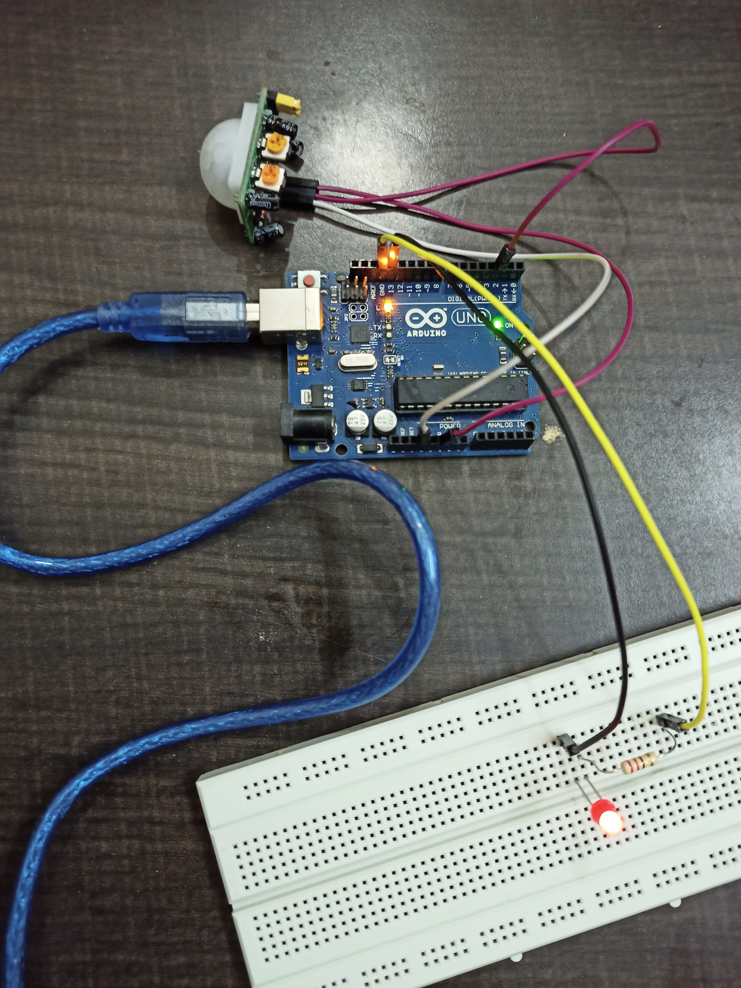

Control home appliances remotely using voice assistant and phone.

1. Components used-:
   * Breadboard
   * ESP8266 Nodemcu v3
   * 4 channel 5v-relay
   * Breadboard power supply module or connect nodemcu with pc.
   * 2 Bulbs
   * 1 Dc motor
   * 1 plastic fan

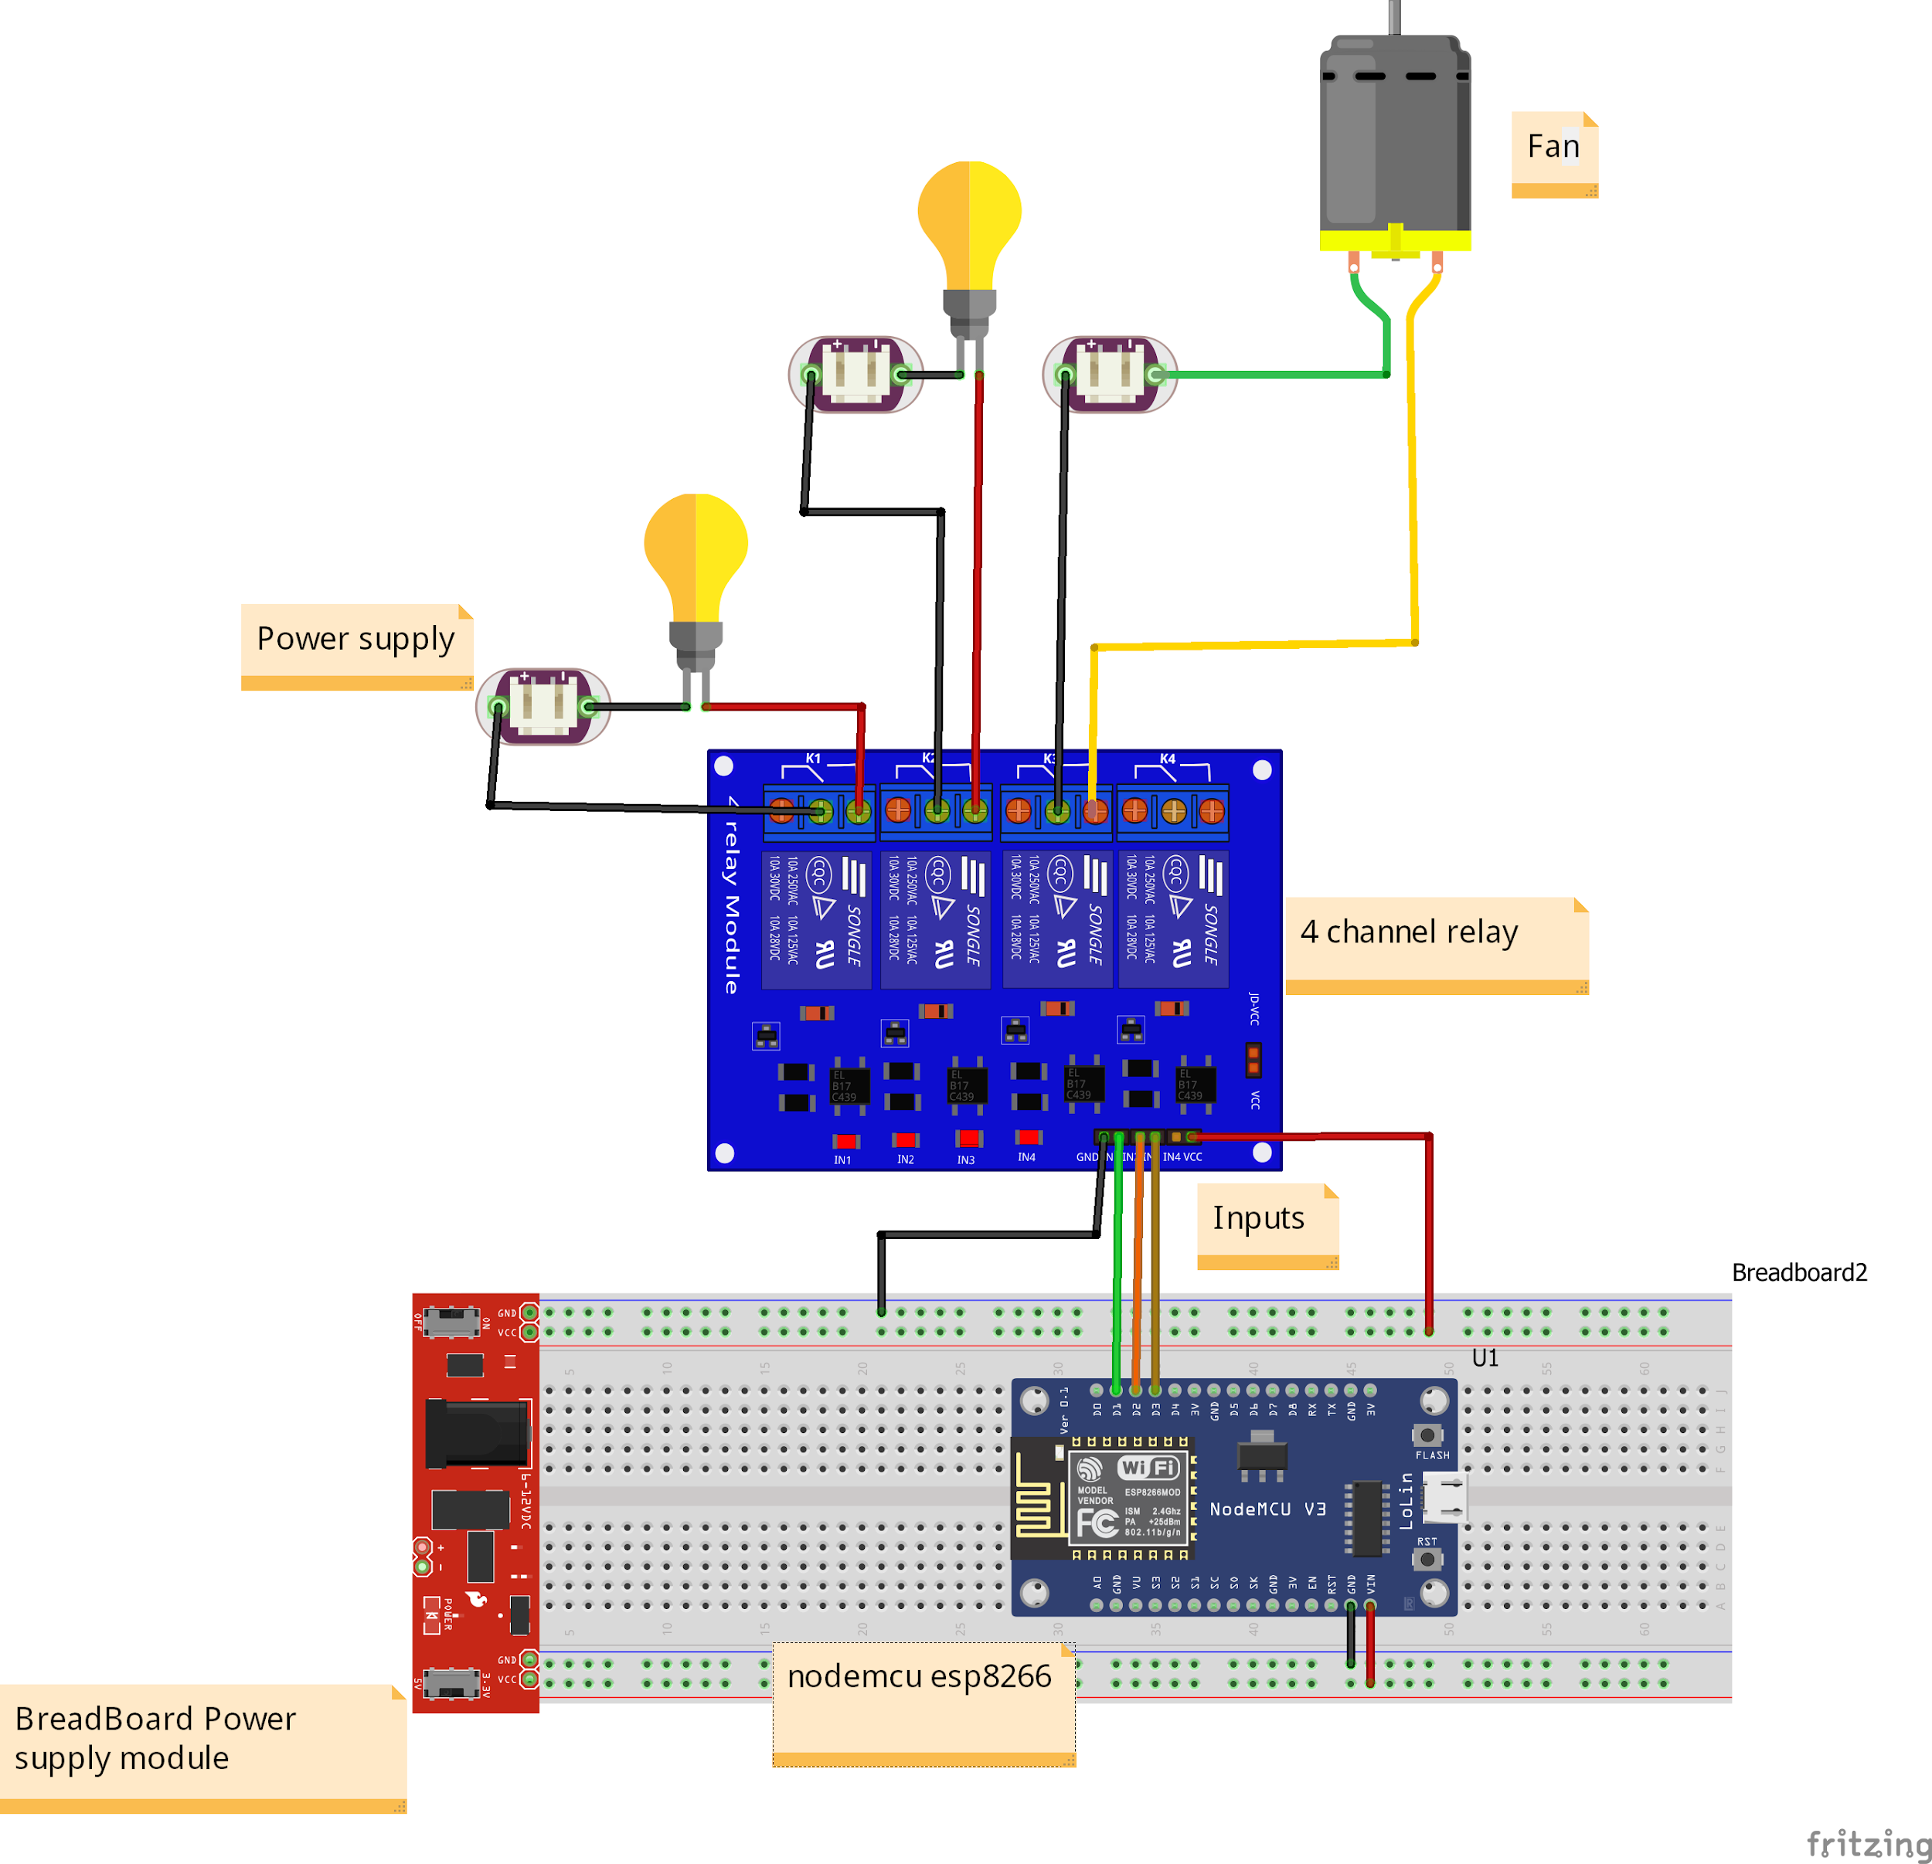

Flow chart-:

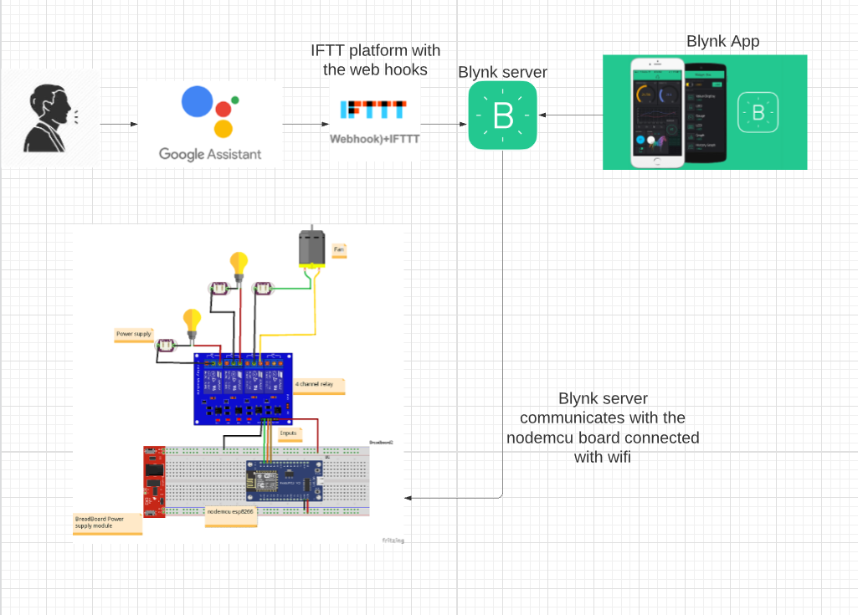

Working -:

**We can control the home appliance in two ways-:**

1. **By using Blynk app**-: Blynk app is connected with the ESP8266 nodemcu with the wifi, (Auth token is provide by blynk app to connect ) , button are made in the blynk app to control the appliances remotely.(Same pin number must be provided to which it is connected in the nodemcu board).

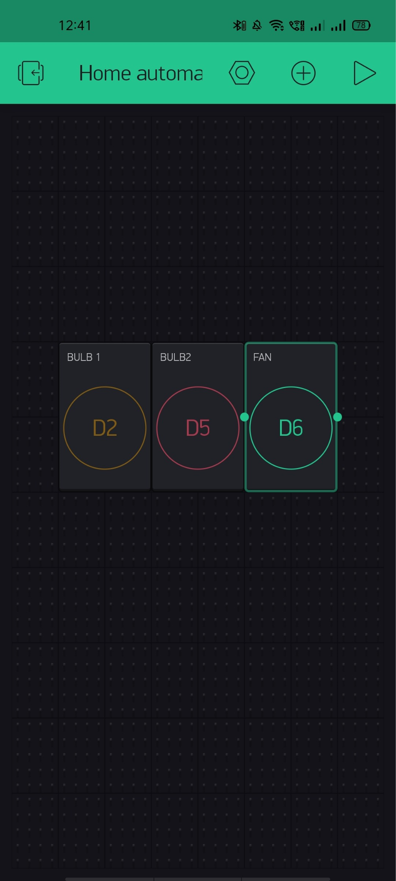

1. **By using google voice assistant** -: To control the appliances with voice assistants we needed to create applets in IFTTT platforms using webhooks that communicate with the blynk server and that communicate with the nodemcu board to control the appliances.

Web hook to trigger the bulb to turn on.

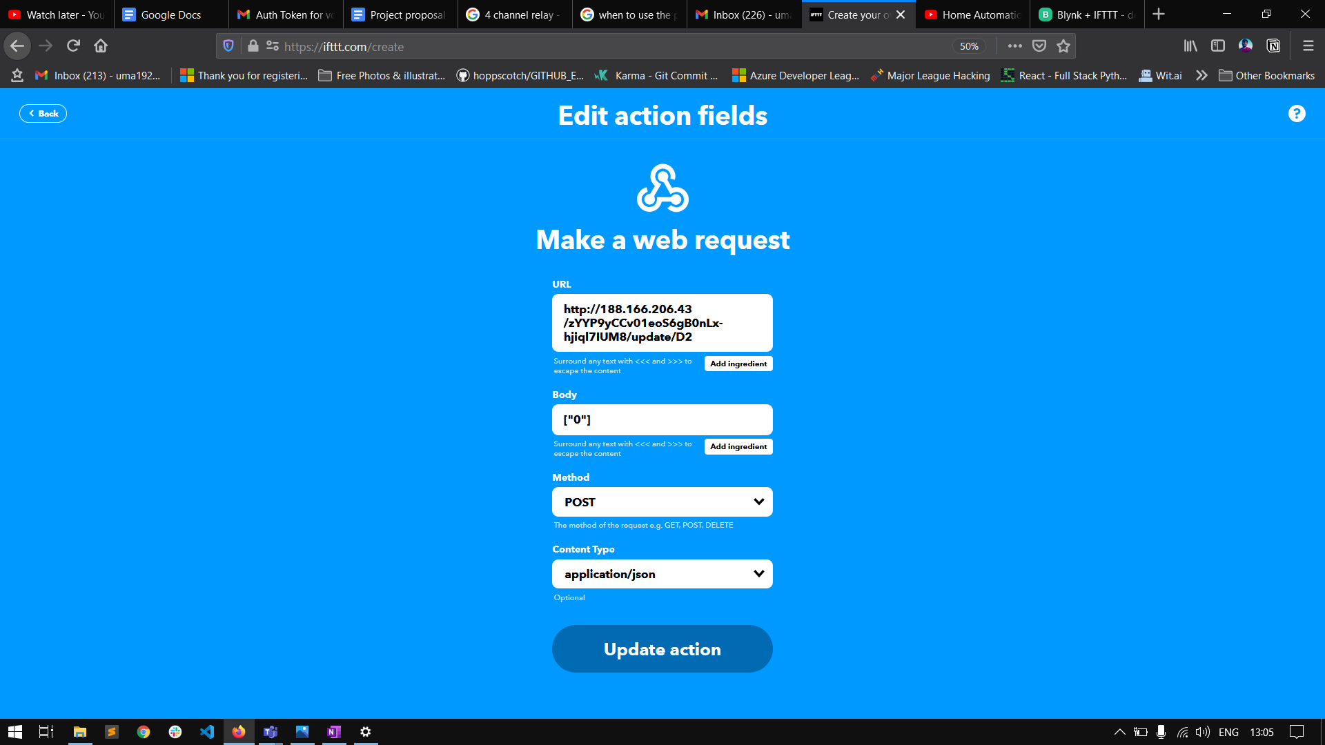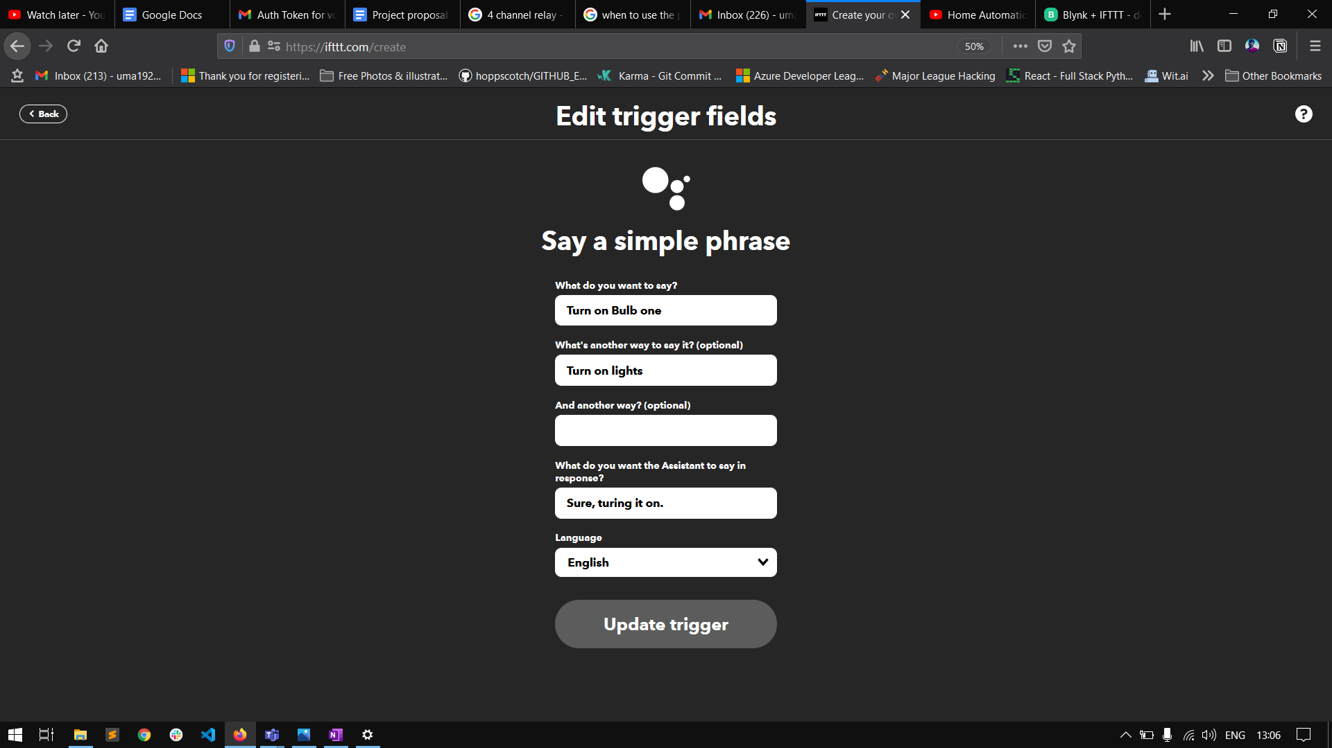

Web hook to trigger the bulb to turn off.

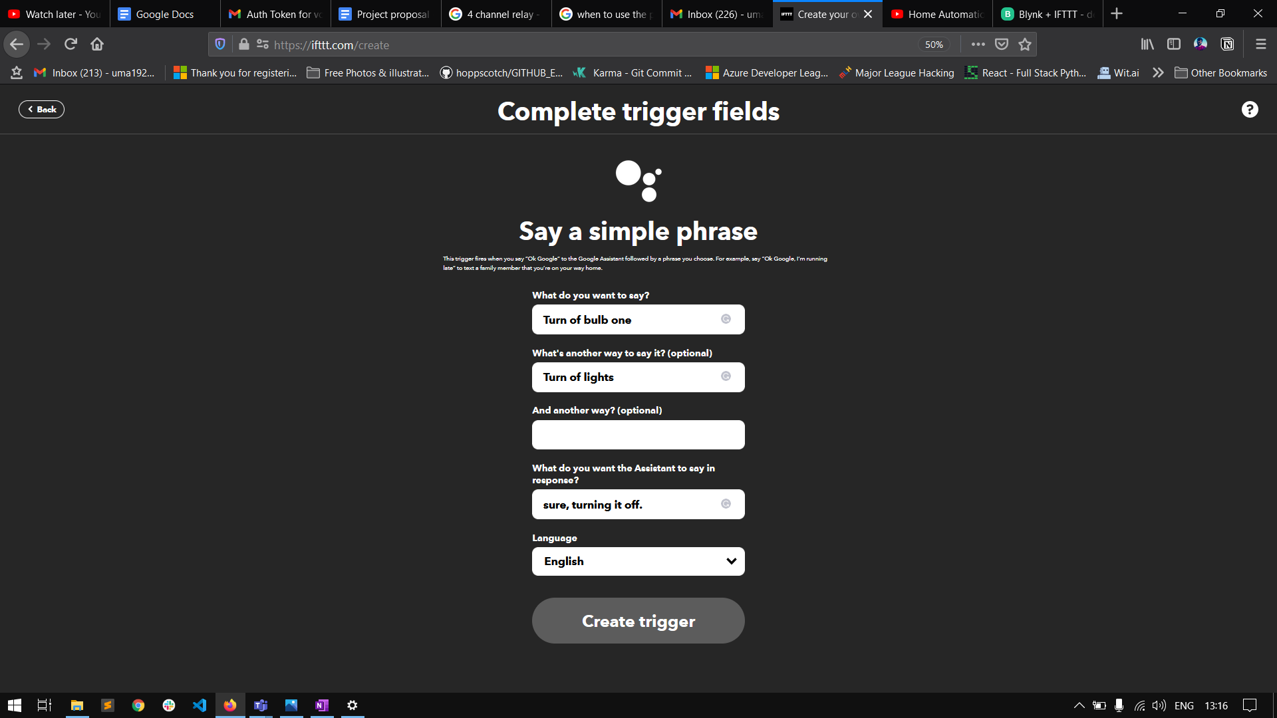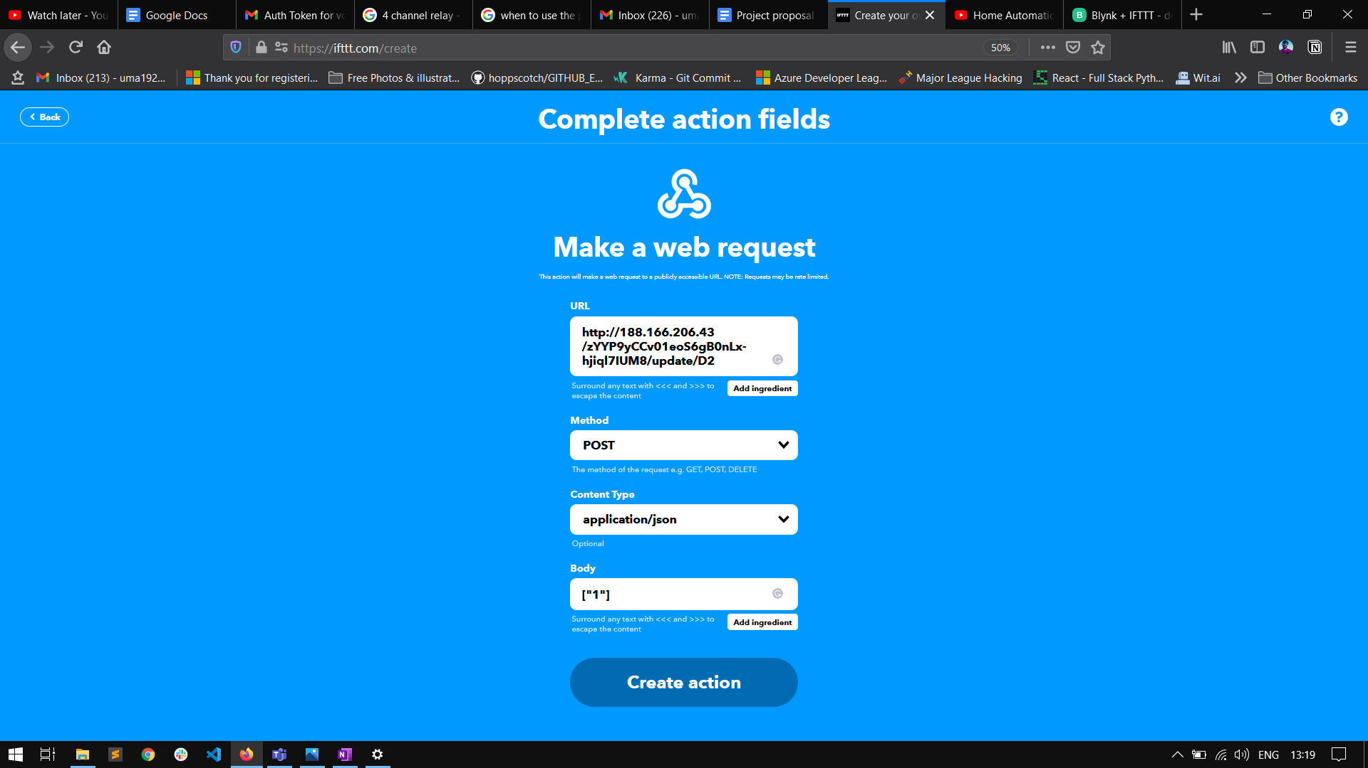

LPG gas leakage detector

**Components Used:**

1. Arduino Uno R3
2. Breadboard Small
3. Micro Servo motor
4. LPG Gas Sensor MQ6
5. Resistor
6. LED
7. Piezo buzzer

**Circuit Diagram:**

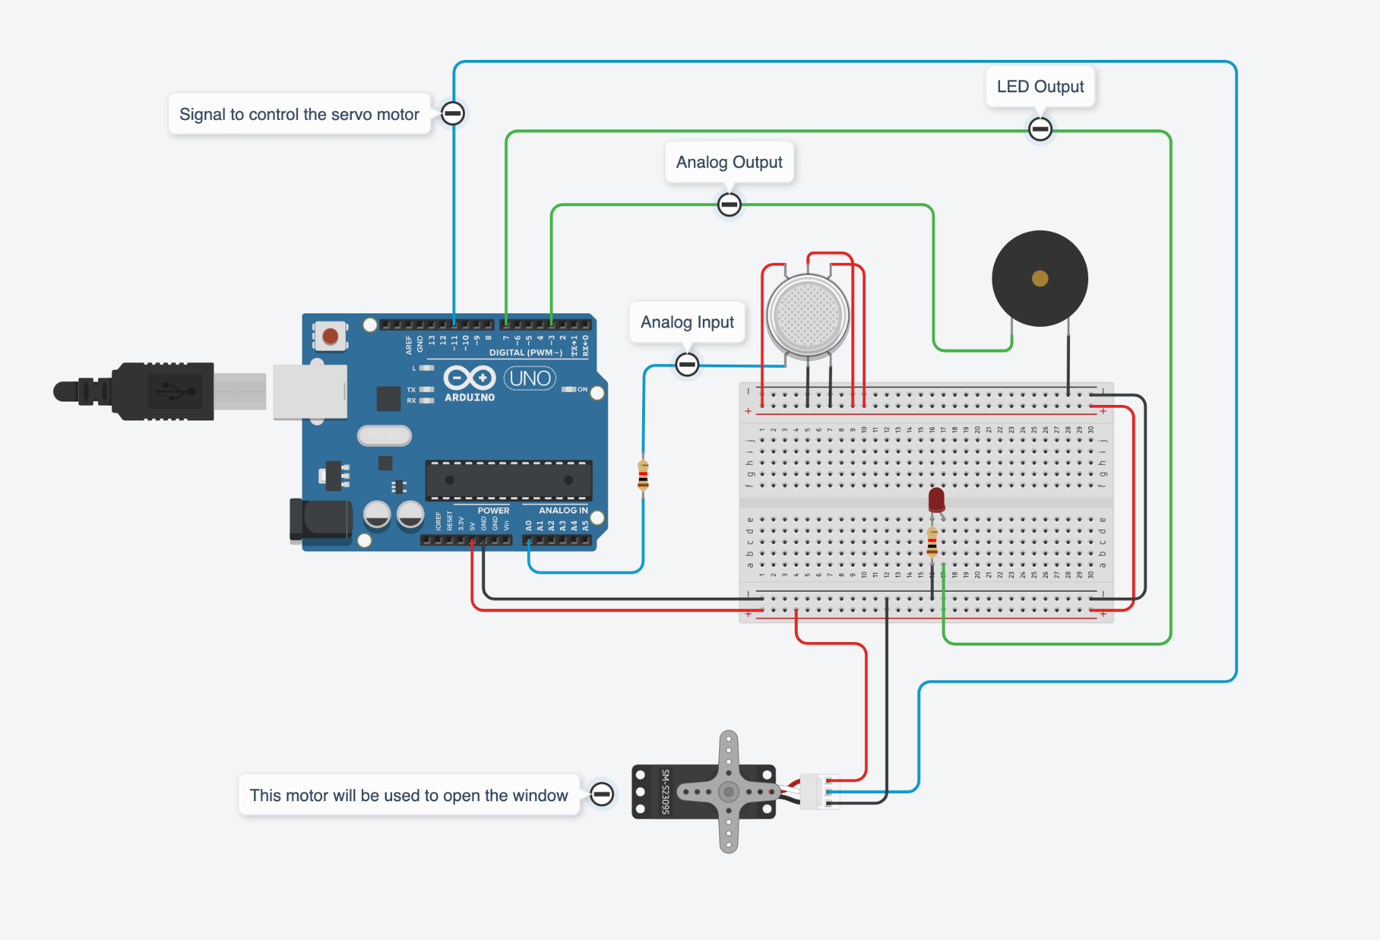

**Description:**

MQ6 (LPG Gas Sensor) is a simple-to-use liquefied petroleum gas (LPG) sensor. In the above circuit is used as gas leakage detecting equipment, this sensor has high sensitivity to Propane, Butane and LPG, also response to Natural gas thus it is suitable for detecting gas leakage.

The Motor is used to open the window once the gas gets detected.

Piezo Buzzer to alert the end user for the same so that they can also take the necessary actions.

If there is gas leakage somewhere near the MQ6 will detect the LPG and Arduino will send a signal to the motor to open the window and there will be an alarm and LED light will start blinking so the even the user can open the window.If the window is already opened then the motor will set to its initial position.